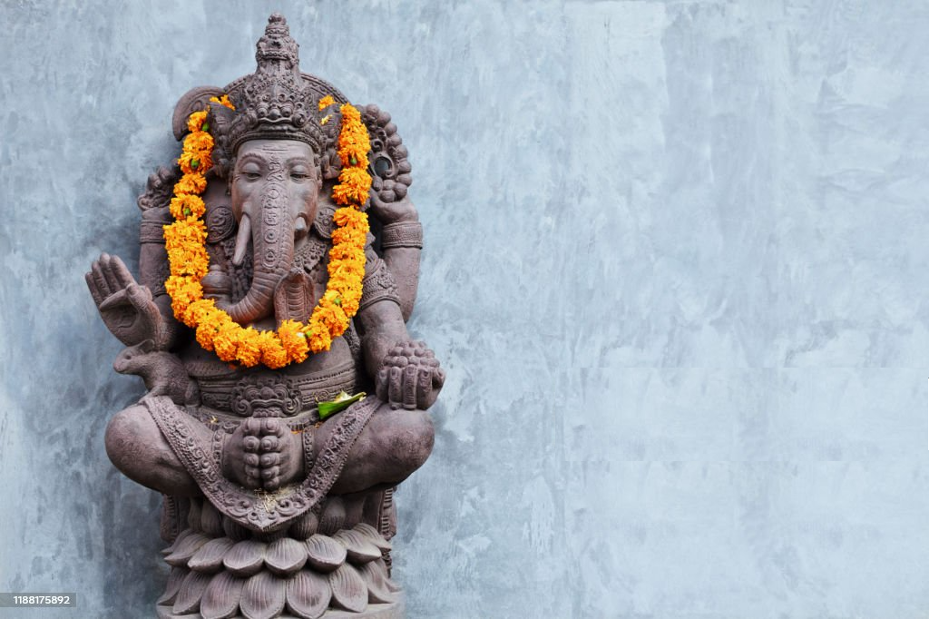

Bali Soul Retreat Application Form

Aug 31- Sat Sep 6, 2025.

Full name: _________________________________________ Date of Application: ____________________

Date of Birth: __________________­­________ Phone:_____________________

Email Address: ______________________________________________________________

Prior yoga experience YES / NO What style of yoga do you practice?

**General Health**

Do you have any  Injuries  Illness  Mental Health conditions?

Do you take medication? Please list

­­­­­­­­­­­­­­­­­­­­­­­­­­­­­Do you have any food allergies or special food requests?

**Room Options - Please tick your preferred option**

Single Resort Room $3220

Twin share Resort Room $2580 *Please indicate sharing partner (if known) __________________

*Please note that room upgrades are available on request.

**Confirmation**

To confirm your place a 25% deposit is due with this Application form

1. **Single Deposit** - $805
2. **Twin Share Deposit** - $645

**Payment Details**

Jill Harris

BSB: 774 001

Account: 226591628

*Please write your name as reference when making deposit

**Terms and Conditions**

1. To join us for Bali Soul Retreat, a 25% deposit can be paid to the account listed above along with this booking form returned to either Dani or Jill to secure your place. Please add your payment confirmation number so that your deposit can be noted. Please refer to the Payments/FAQ form for payment plan options.
2. In the event of cancellation by you the following applies:

If your place can be filled, you will receive a full refund, minus a $100 admin fee.

If your place is not filled, you may be eligible for a 30% refund depending on the time out from the retreat.

1. Please Note: Dani Pritchard Yoga & Kyo Yoga & Healing are not responsible for your flights, transfer costs or travel insurance.
2. Dani Pritchard Yoga and Kyo Yoga & Healing are not responsible for any illness or injuries incurred whist travelling to and from or during your spare time on the retreat.
3. During our classes together always honor yourself, stop, rest and inform either Jill or Dani if at any stage you feel unwell.
4. Dani Pritchard Yoga and Kyo Yoga & Healing cannot accept any responsibility for loss or damage of personal possessions or valuables during your stay on the retreat.

Please sign if you agree to the terms and conditions.

Signature: Date: ­­­­­­­­­­

Namaste! We look forward to welcoming you on the retreat.

Jill & Dani

Office Use Only

Payment Option 1: Deposit____ Payment 1_____ Payment 2 (Final)_____

Payment Option 2: Deposit_____ Feb____ March____ April_____ May_____ June_____ July_____